# validation

The validation procedure intends to check the performance of the Brazilian version of the COPA model. In order to attend this objective, we compared results of COPA with the observed dispatch of electricity generation as provided by the Brazilian National System Operator (ONS). We analyzed the dispatch for one year, 2012, on a daily basis. Although COPA is an hourly model, ONS makes available data on a daily basis only, which is the reason we compare the results on that temporal resolution.

We used data from the Newave deck of December 2012. This is the software used to plan the monthly electrical system operation in Brazil. The electricity Commercialization Chamber (CCEE) publishes the deck containing all information used as input to Newave in each month (Electricity Commercialization Chamber 2012). We used data related to hydro power generation capacities in all subsystems, transmission lines capacities, and variable costs of thermal plants in operation by December 2012. Besides this data, we used some more information from the ONS website, such as hydro inflows (National System Operator 2017b) and reservoir parameters (initial and final levels and maximum capacity) (National System Operator 2017c). Hourly load data was obtained by mail correspondence with ONS (National System Operator 2017a).

We have also derived installed wind capacity data from the electricity market regulator website (Electricity National Agency 2017). In terms of hourly time series of wind capacity factors, we collected data at the Renewables Ninja website (Staffell and Pfenninger 2016).

In order to make sure we were working with consistent input data, we verified if the temporal profile of renewable resources was valid. We observed that inflows during the humid period were higher than in the dry one in all subsystems. We observed greater wind resources during the dry period than the humid one as well.

The validation begins with the fixation of initial and terminal levels of each subsystem reservoirs. We obtained this information on the ONS website (National System Operator 2017c) and restricted the model accordingly. This was necessary in order to avoid the model to empty all reservoirs by the end of the period. This would happen if reservoir levels wouldn’t be restricted, because hydro generation has zero variable costs.

After running the model and gathering outputs, we compared total inflows and total hydro electricity generation of ONS and COPA. COPA was overestimating the hydro-generation in comparison to observations by 7%. The cause of this deviation can be (a) the fact that we do not model evaporation of water in reservoirs and (b) we do not model the influence of storage levels on hydropower generation performance (i.e. lower reservoir levels reduce the energy content of the stored water). In order to correct that, we`ve multiplied COPA inflows by 93%, which we call inflow calibration factor. Figure 1 and Figure 2 show total hydro generation of ONS and COPA on a daily basis and on monthly basis after correction. The Figure 1 shows the thermal generation from ONS and COPA.



Figure 1: Hydro total generation. Daily basis

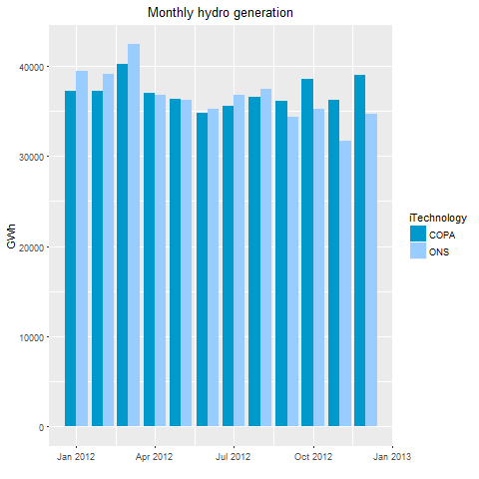

Figure 2: Monthly hydro generation

There are some differences in hydro generation mainly at the end of the year probably because COPA does not deal with the hydrological uncertainties (as it is deterministic).

Besides the fact that inflows are not certain, the second half of the year is the driest period in Brazil usually, and so it may justify greater thermal dispatch by ONS. Other factors to be considered is that the load is uncertain as well. It has a well-defined shape depending on the season of the year, but the load peak is always suitable to changes in terms of value and the day time it occurs. Sometimes it is necessary to dispatch more thermal plants to deal with rapid load changes.



Figure 3: Thermal total generation. Daily basis

A third uncertainty during the operation of Brazilian electrical system is associated with the installation of new plants. Sometimes dispatch is planned ahead assuming that power plants are available in the future, although installation takes longer than planned. If that is the case, additional thermal generation may have to be dispatched later (i.e. more than planned) to balance load with generation. The deterministic COPA model, where everything is known, minimizes thermal power generation, as it is the only form of generation with variable costs. Additionally, it is going to minimize the dispatch of peak load plants, as those are much more costly. This is possible in a deterministic model, real dispatch, in particular in hydropower dominated systems, however, faces uncertainties which increases the use of peaking power plants.

Figure 4 shows the examination of wind generation. We observe a shape compatible with the wind profile in Brazil. This means less production during the wet period and more generation during the dry period. While both, COPA and ONS follow this profile, COPA is more optimistic between July and October. The wind generation takes place in two subsystems: Northeast and South.

In terms of comparison by regions, Table 1 shows the correlation and root-mean-square deviation (RMSE) from ONS and COPA generation. The greatest correlation is observed in hydro generation in North region (81%) and the smallest RMSE is observed in thermal generation in the Northeast region (0.13).

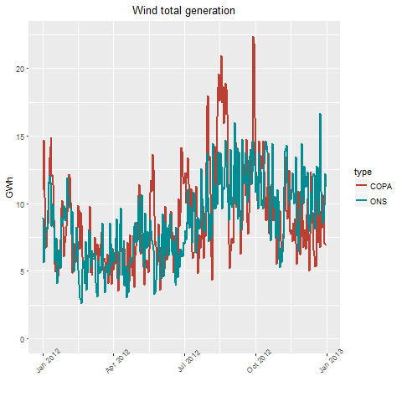

Figure 4: Wind total generation. Daily basis

Table 1: Statistical indicators per region

|  |  |  |  |
| --- | --- | --- | --- |
| Region | Technology | Correlation | RMSE |
| Southeast (SE) | Hydro | 0.64 | 78.97 |
| Southeast (SE) | Thermal | -0.09 | 2.22 |
| South (S) | Hydro | 0.28 | 55.69 |
| South (S) | Thermal | 0.01 | 0.25 |
| South (S) | Wind | 0.42 | 1.26 |
| Northeast (NE) | Hydro | -0.01 | 56.87 |
| Northeast (NE) | Thermal | 0.00 | 0.13 |
| Northeast (NE) | Wind | 0.47 | 2.33 |
| North (N) | Hydro | 0.81 | 29.73 |
| North (N) | Thermal | NA | 0.00 |

Source: Own Elaboration

However, the best approach is considering both indicators together instead of isolated. Doing so COPA’s best performance is with respect hydro and wind generation. These numbers show that COPA and ONS results have similar paths with a reasonable root-mean-square deviation when it comes to hydro in the Southeast and North and wind on South and Northeast.

Concluding, taking into account that COPA is a deterministic model, we do not deal with hydrological, load and planning uncertainties. It has perfect foresight, knowing all the inflows and load variations at the beginning of the period. Because of that, differences between real operation and the model have to be expected. In terms of application of the model, that means that integration costs of uncertain resources (in particular hydropower, wind, and solar PV) are underestimated.

# references

Electricity Commercialization Chamber, CCEE. 2012. “Newave input files deck.” https://www.ccee.org.br/search/query/search?search.timezone=-60&search_startnum=&search_endnum=&num=10&search_dupid=&exttimeout=false&actProfId=0&group=&q=deck+de+pre%C3%A7os+Newave+12%2F2012&btnSearch=Search&search_p_main_operator=all&search_p_atname=&adn=&search_p_op=equals&search_p_val=&search_p_atname=&adn=&search_p_op=equals&search_p_val=.

Electricity National Agency, ANEEL. 2017. “Brazilian electricity wind generation capacity.” http://www2.aneel.gov.br/aplicacoes/capacidadebrasil/GeracaoTipoFase.asp.

National System Operator, ONS. 2017a. “Brazilian electrical system load information,” May 2, 2017. https://mail.google.com/mail/u/0/?tab=mm#search/wilkens%40ons.org.br/15bc9a41d3e01573.

———. 2017b. “Hydrological data - inflows.” http://www.ons.org.br/Paginas/resultados-da-operacao/historico-da-operacao/dados_hidrologicos_vazoes.aspx.

———. 2017c. “Stored energy.” http://www.ons.org.br/Paginas/resultados-da-operacao/historico-da-operacao/energia_armazenada.aspx.